**A CRM APPLICATION FOR ENGINEERING WORKS**

**Project Overview**

**Introduction**

Introduce the CRM application for engineering works. Describe its purpose in solving challenges like project tracking, client communication, data handling, and resource management. Highlight its significance in centralizing engineering data and automating workflows.

The CRM application for engineering works aims to revolutionize project and client management by centralizing all critical data and automating key processes. By integrating tools for tracking projects, managing resources, and enhancing client communication, the system seeks to improve operational efficiency and foster collaboration among teams.

With features like real-time updates, automated notifications, and custom dashboards, the CRM ensures seamless project execution while offering actionable insights for informed decision-making. Additionally, its scalable design and robust data security measures make it a reliable solution for growing engineering businesses, supporting their long-term goals and evolving needs.

## Definition_and_Importance_of_CRM_in_Business_Operations

A CRM system allows businesses to streamline communication and relationships with customers. It helps manage customer data, automate tasks, track interactions, and provide insights into customer behavior, which in turn leads to better decision-making. The importance of CRM lies in its ability to enhance customer satisfaction, loyalty, and retention, while also contributing to the growth of sales and profitability.

## The_Use_of_Salesforce_for_this_CRM_Application

Salesforce is a widely used cloud-based CRM platform, offering powerful tools for managing customer relationships, tracking leads, and automating sales processes. It is highly customizable and scalable, making it ideal for businesses of all sizes. For this CRM application, Salesforce has been utilized to build a robust, efficient system that supports the automation of tasks, data management, and reporting functions.

## Purpose and Scope of_the CRM Application

The purpose of this CRM application is to provide an efficient platform for managing customer interactions, sales processes, and customer service functions. It aims to improve business operations by enhancing the way customer data is organized and accessed. The scope of the application includes managing customer information, tracking project details, and streamlining communication between teams, ensuring better customer satisfaction and operational efficiency.

# Project Objectives

## Business Goals

The primary business goals of this CRM application are to improve client relationship management, streamline work order tracking, and enhance communication and collaboration across various teams. The application aims to centralize client data, allowing businesses to better understand customer needs and tailor services accordingly. It will also help track work orders from initiation to completion, ensuring timely delivery and efficient project management. By automating key tasks and providing real-time data, the CRM will improve decision-making, reduce manual errors, and ultimately contribute to higher customer satisfaction and profitability.

## Client_Relationship_Management

A key goal is to build and maintain strong client relationships by providing a user-friendly interface that allows easy access to client data, project updates, and communication history. This ensures that all interactions with clients are consistent, personalized, and tracked efficiently.

## Work_Order_Tracking

The application will track work orders from creation through to completion, ensuring that all tasks are assigned, monitored, and delivered on time. It will allow project managers to oversee progress, allocate resources effectively, and ensure the quality and timeliness of deliverables.

## Target Users

The CRM application is designed for multiple user groups, including engineering teams, clients, and project managers, each with different roles and responsibilities.

* **Engineering Teams**: Engineering teams will use the CRM to view and update project details, track work orders, and collaborate with other teams. They will have access to task lists, timelines, and client specifications, enabling them to work efficiently.
* **Clients**: Clients will use the CRM to access information about their ongoing projects, track work progress, and communicate with the project teams. This feature enhances transparency and strengthens client trust.
* **Project Managers**: Project managers will use the CRM to oversee all project aspects, including work orders, resource allocation, team performance, and client communication. They will have a comprehensive view of all ongoing projects, allowing them to make data-driven decisions and ensure project success.

# System Design and Architecture

## Salesforce_Overview_and_Reasons_for_Choosing_Salesforce

Salesforce is a leading cloud-based CRM platform that provides comprehensive tools for customer management, automation, and analytics. It is highly customizable and scalable, making it suitable for businesses of all sizes. Salesforce offers various features such as customizable objects, workflows, and automation tools that streamline operations. For this CRM application, Salesforce was chosen because of its flexibility, ease of use, and integration capabilities. It allows for seamless handling of customer data, automation of tasks, and realtime insights, ensuring a smooth and efficient business operation.

## Data_Model_Design

The data model is designed to ensure the effective management of client and project information. The following key objects are used:

* **Accounts**: Represents businesses or organizations that the company works with. An account can contain details such as company name, industry, address, and related contacts.
* **Contacts**: Stores information about individuals within the accounts. Each contact holds personal details like name, email, and role within the organization.
* **Opportunities**: Tracks potential sales and projects related to an account. Opportunities are associated with specific accounts and contacts, allowing the sales or project management teams to monitor progress and forecast revenue.
* **Custom Objects**: To meet specific business needs, custom objects are created, such as “Work Orders,” “Engineering Tasks,” or “Project Milestones.” These objects store unique data related to the company’s workflow and ensure the CRM is tailored to the business’s requirements.

## Tools Used

Several tools within Salesforce are leveraged to build a dynamic and automated CRM system:

* **Salesforce Lightning**: A modern user interface that provides a responsive and intuitive experience for users. It allows for customizable pages and components, making it easier for teams to access and manage critical data.
* **Flows**: A powerful tool to automate business processes and guide users through complex workflows. Flows help automate tasks like work order creation, approval processes, and notifications, reducing manual efforts.
* **Process Builder**: This tool enables the automation of business processes by creating workflows based on specific triggers. It helps automate tasks such as updating records, sending emails, or creating tasks when certain conditions are met, ensuring a seamless process flow within the CRM system.

## Key Features of the CRM Application

* **Client_Management**

Client management is at the core of the CRM application, enabling businesses to track detailed client information and interactions. Each client (Account) in the system stores key details such as company name, contact information, project history, and communication logs. The CRM provides a centralized platform for managing client relationships, making it easier to view client-specific data, track progress, and facilitate communication across teams. This helps ensure that every interaction with the client is personalized, timely, and recorded for future reference.

* **Work_Order_Management**

Work order management is an essential feature that allows businesses to create, assign, and track work orders efficiently. Users can create work orders linked to specific clients, outlining the required tasks, deadlines, and resources. The system enables project managers to assign tasks to engineering teams, monitor progress, and ensure that work is completed within the stipulated timeframe. Automated reminders and updates keep everyone informed, reducing delays and improving task management. Clients can also track the status of their work orders, enhancing transparency and client satisfaction.

* **Invoicing_and_Payment_Tracking**

The CRM includes a robust invoicing and payment tracking system to manage client billing and payments. Invoices can be generated automatically based on completed work orders, with customizable templates that meet business requirements. Payment statuses are tracked within the system, providing up-to-date information on outstanding or paid invoices. Automated reminders can be sent to clients for overdue payments, and project managers can access financial reports for better decision-making. This feature streamlines the financial processes and ensures timely payments.

* **Automation_and_Workflows**

Salesforce Flow is used to automate business processes, reducing manual tasks and improving efficiency. Workflows are created to automatically trigger actions, such as task creation, email notifications, or approval processes, based on specific conditions. For example, once a work order is marked as complete, an invoice can be automatically generated and sent to the client. Automating repetitive tasks not only saves time but also ensures consistency and accuracy throughout the system.

* **Reports_and_Dashboards**

Custom reports and dashboards provide real-time insights into key business metrics, such as sales performance, work order status, and client interactions. Users can generate reports based on specific criteria, such as account performance or project completion rates, helping businesses analyze trends and make informed decisions. Dashboards provide a visual representation of important data, allowing project managers and teams to quickly assess project health and client satisfaction. The reporting feature helps monitor KPIs, identify bottlenecks, and drive continuous improvement in business operations.

* Together, these key features ensure that the CRM application enhances operational efficiency, strengthens client relationships, and provides valuable insights for datadriven decision-making.

# Data Model

## Explanation_of_Custom_Objects

The data model is designed to efficiently manage and organize the information critical to business operations. Custom objects are used to capture specific data related to clients, projects, work orders, and invoices:

* **Clients**: The "Client" object stores details about each client (Account), such as company name, address, contact information, and related contacts. This object serves as the primary record for managing relationships with businesses or individuals.
* **Projects**: The "Project" object tracks details of specific projects or services provided to clients. Each project record includes information such as project name, description, start and end dates, assigned resources, and project milestones. Projects are associated with clients, helping to monitor ongoing and completed work for each client.
* **Work Orders**: The "Work Order" object represents specific tasks or service requests tied to a project. It contains data such as task details, deadlines, assigned team members, work status, and any updates or changes. Work orders allow project managers to monitor task progress and ensure that all work is completed as scheduled.
* **Invoices**: The "Invoice" object manages financial records related to each project or work order. It includes invoice numbers, billing details, amounts, due dates, and payment status. Invoices are linked to work orders and projects, allowing businesses to track billing and payments in conjunction with the work completed.

## Relationships_between_Objects

The relationships between these objects are crucial for ensuring that the data model functions seamlessly:

* **One-to-many relationship (Client to Projects)**: One client can have multiple projects associated with them. Each project record is linked to a single client, but a client may have several ongoing or completed projects.
* **One-to-many relationship (Project to Work Orders)**: A single project can have multiple work orders. Each work order is tied to a specific project, allowing the tracking of individual tasks or requests within the larger scope of the project.
* **One-to-one relationship (Work Orders to Invoices)**: Each work order typically generates one invoice, which is directly linked to the work order. This ensures accurate billing and payment tracking for the work performed.

These relationships ensure that each object is connected in a logical manner, allowing users to easily navigate between clients, projects, work orders, and invoices.

## Data_Flow_and_Management

The flow of data within the system is designed to ensure accuracy and consistency at every stage. Data entered into one object automatically updates related objects, preventing data duplication and ensuring real-time synchronization across all records. For example, once a work order is marked as completed, an invoice is generated automatically. Similarly, when a project status is updated, the progress is reflected across all related work orders.

To maintain data accuracy, validation rules and automated workflows are implemented. These ensure that all required fields are completed, and no inconsistent or incomplete data enters the system. Regular data audits and validation checks are performed to ensure that the information remains correct and up-to-date.

Additionally, data consistency is maintained by linking related records (clients, projects, work orders, and invoices) and ensuring that all actions are tracked within the system, so any updates or changes are reflected across related records in real time. This approach helps avoid discrepancies and provides a clear, accurate view of business operations.

# Automation and Workflows

## Salesforce_Flow_for_Task_Assignment_and_Notifications

Salesforce Flow is a powerful tool used to automate various tasks within the CRM application. For task assignment, Salesforce Flow automatically assigns work orders to the relevant engineering teams or project members based on predefined rules, such as resource availability or expertise. For example, when a new work order is created, the system can trigger a flow to assign it to the appropriate engineer based on the project’s scope or task type. This ensures that no task is missed and resources are allocated efficiently.

Additionally, notifications are triggered through Salesforce Flow to inform users about updates, such as task assignments, work order status changes, or project milestones. Engineers or project managers receive real-time alerts whenever a new task is assigned, or an existing task is updated. This automation reduces manual oversight and ensures that team members stay informed and focused on their responsibilities.

### Process_Builder_for_Automating_Client_Follow-Ups_and_Invoice_Reminders

Salesforce’s Process Builder allows businesses to automate client follow-ups and invoice reminders, improving communication efficiency. When a specific condition is met, such as a pending work order or overdue invoice, Process Builder automatically triggers predefined actions. For instance, when an invoice is generated, a follow-up reminder can be automatically scheduled to be sent to the client after a set period, such as 7 or 14 days.

The same process can be used for invoice reminders—when a due date is approaching or a payment is overdue, Process Builder can send automated email reminders to clients, reducing manual intervention and improving cash flow. These automated follow-ups ensure timely communication with clients without burdening the team with repetitive tasks.

## Email_Alerts_and_Notifications_for_Client_Communication

Email alerts and notifications are essential for effective client communication. The CRM application uses Salesforce's email alert functionality to automate client communications, such as sending work order confirmations, status updates, and invoice reminders. For instance, once a work order is completed, an email is sent automatically to the client notifying them of the completion and any necessary next steps.

In addition, project managers and engineers receive real-time email alerts about task assignments, project updates, or client requests, ensuring that everyone stays aligned. These alerts can be customized to suit different communication needs, ensuring timely and relevant communication with clients and internal teams.

By automating these processes using Salesforce Flow, Process Builder, and email alerts, the CRM application reduces manual work, improves response times, and enhances overall operational efficiency. These workflows ensure that both clients and internal teams are always up-to-date with project progress and financial matters.

# Reports and Dashboards

**Creating Custom Reports for Project Status, Client Interactions, and Performance** The CRM application offers customizable reporting tools to track and analyze key business data. Users can generate custom reports tailored to specific needs, such as tracking the status of ongoing projects, monitoring client interactions, and evaluating team performance. For example:

* **Project Status Reports**: These reports allow project managers to track the progress of each project, highlighting milestones achieved, pending tasks, and deadlines. The reports provide a clear overview of all active projects and their current status, helping managers prioritize tasks and allocate resources effectively.
* **Client Interaction Reports**: This type of report focuses on tracking communication with clients, including meetings, emails, and follow-up actions. It provides a historical record of interactions, helping teams understand client needs, identify potential issues, and improve engagement strategies.
* **Performance Reports**: These reports assess the performance of both the team and individual members. They may include metrics such as task completion times, the number of work orders assigned/completed, and client feedback, helping managers evaluate team productivity and identify areas for improvement.

## Overview_of_Dashboards_with_Key_Metrics

Dashboards provide a visual representation of key business metrics, offering users real-time insights into their work and performance. Dashboards are highly customizable, allowing users to display metrics that are most relevant to their role. Common metrics displayed on the dashboards include:

* **Project Progress**: Visual progress bars, Gantt charts, or task completion percentages show how much of a project has been completed and what's left to be done.
* **Work Order Status**: A summary of open, in-progress, and completed work orders, helping project managers and engineers stay updated on task statuses.
* **Client Metrics**: Metrics such as the number of active clients, upcoming invoices, and payment statuses, offering a quick snapshot of client engagement and financial health.
* **Performance Metrics**: This includes key performance indicators (KPIs) like average task completion time, number of tasks completed per employee, and client satisfaction ratings.

These dashboards are designed to provide users with easy-to-understand visuals such as graphs, pie charts, and bar charts that allow for quick decision-making and monitoring of essential business metrics.

## Data_Analysis_and_Decision_Making_Based_on_Reports

Reports and dashboards offer the foundation for informed decision-making by providing accurate, real-time data analysis. By reviewing custom reports and monitoring key metrics on dashboards, managers and team leads can identify trends, monitor performance, and make datadriven decisions. For example:

* If project status reports show delays in specific tasks, project managers can investigate the causes and take corrective actions to prevent future delays.
* Performance reports can reveal individual team members' productivity levels, helping identify training or support needs.
* Client interaction reports can highlight patterns in client communication, helping improve relationship-building efforts and client retention.

The ability to analyze this data allows businesses to make timely decisions, such as adjusting resource allocation, improving customer service, or addressing performance gaps, ultimately driving better outcomes for both the company and its clients.

By integrating these reports and dashboards, the CRM application empowers users to track progress, manage tasks, and make proactive decisions based on real-time insights, ensuring efficient operations and continuous improvement.

# Testing and Quality Assurance

## Testing_Approach

The testing phase of the CRM application is designed to ensure that all features work as intended and meet the requirements of the users. The approach includes the following key types of testing:

* **Functional Testing**: This type of testing focuses on validating the functionality of the application. Each feature, such as task assignment, client management, work order creation, and invoicing, is tested to ensure it performs as expected. Functional tests are conducted for both standard use cases and edge cases to ensure that all features are robust and reliable under different conditions.
* **User Acceptance Testing (UAT)**: UAT is performed by actual users (project managers, engineers, and admins) to ensure the application meets their needs. During UAT, users test the CRM application in real-world scenarios to verify that it aligns with their expectations. This phase helps identify any usability issues or missing features that need to be addressed before deployment.

## Bug_Fixes_and_Issue_Resolution

Throughout the testing process, bugs and issues are identified and documented. A systematic approach is followed to resolve these issues:

* **Issue Tracking**: Any bugs discovered during testing are logged into a bug-tracking system, with detailed descriptions of the issues, steps to reproduce them, and their severity level.
* **Bug Fixing**: Development teams work to resolve these issues, making necessary code changes or adjustments to system configurations. After each bug fix, the issue is retested to ensure the problem is resolved without introducing new issues.
* **Regression Testing**: After fixes are implemented, regression testing is conducted to ensure that the changes do not negatively affect other parts of the application. This ensures that previously working features remain functional after updates or fixes.

## Final_Validation_Before_Deployment

Before the CRM application is deployed to production, a final validation phase is performed to ensure all components are functioning as expected:

* **End-to-End Testing**: This involves testing the entire workflow of the application, from client registration to project completion and invoicing, to ensure that all integrated features work together smoothly.
* **Performance Testing**: The application is tested under heavy load to ensure it performs efficiently with a large number of users or complex datasets. This helps identify any performance bottlenecks or issues that could arise during normal usage.
* **Security Testing**: Security features, such as user authentication, role-based access control, and data encryption, are tested to ensure the application is secure from potential threats.

Once the CRM application passes all testing phases, including UAT, bug fixes, and final validations, it is ready for deployment. This thorough testing process ensures a high-quality, reliable product that meets the needs of users and maintains operational integrity post-launch.

# Challenges Faced and Solutions

## Data_Migration_Issues

One of the significant challenges faced during the development of the CRM application was migrating data from legacy systems to Salesforce. Legacy systems often store data in formats that are not directly compatible with Salesforce, leading to potential issues with data integrity and consistency.

• **Solution**: To address this challenge, a detailed data mapping plan was created to identify the structure and fields of legacy data and align them with Salesforce’s data model. We used Salesforce’s data import tools, such as the Data Loader, to facilitate smooth migration. In addition, data cleansing was performed to eliminate any duplicates or outdated information, ensuring that only accurate, relevant data was transferred into the system. The migration process was done in phases, with extensive testing to ensure that all data was correctly imported and functional in the new system.

## Customization_Challenges

Salesforce is a highly customizable platform, but adapting it to fit the specific business processes and needs of the engineering firm presented challenges. The business required tailored workflows, custom objects, and automation that went beyond the standard Salesforce functionality.

• **Solution**: The customization process involved working closely with business stakeholders to understand their unique requirements and translating those needs into Salesforce configurations. Custom objects were created to manage engineering-specific data, such as projects, work orders, and client interactions. Salesforce Lightning components were used to enhance the user interface, and Salesforce Flows were built to automate complex workflows, such as task assignments and invoice reminders. By leveraging Salesforce’s flexibility, the platform was customized to ensure it fully supported the company's operations without compromising system performance.

## User_Adoption_and_Training

Adopting a new CRM system can be difficult, particularly when employees are accustomed to legacy tools or manual processes. Resistance to change and a lack of familiarity with Salesforce’s features posed a challenge to user adoption.

• **Solution**: To overcome this challenge, a comprehensive training program was developed for different user groups, including admins, project managers, and engineers. The training program included hands-on workshops, video tutorials, and user manuals, ensuring that users could learn how to navigate and use the system effectively. Additionally, user feedback was regularly collected to identify pain points, which were addressed through additional training or system refinements. A dedicated support team was set up to assist users with any issues, ensuring that any difficulties with the new system were resolved promptly.

# Output

## Picture 1

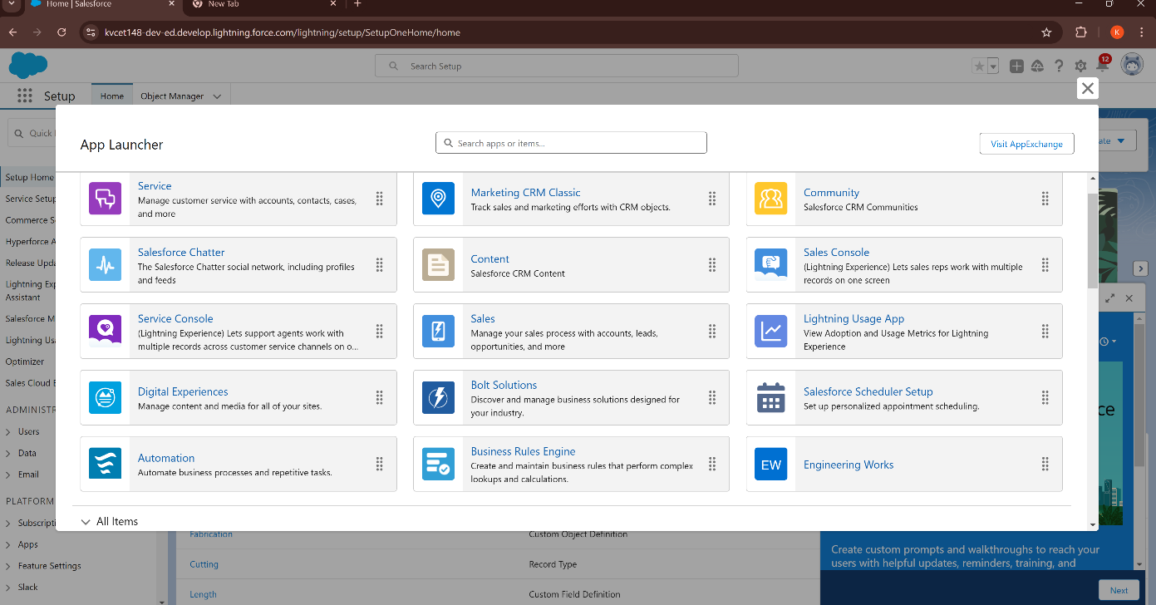

## Picture 2

## Picture 3

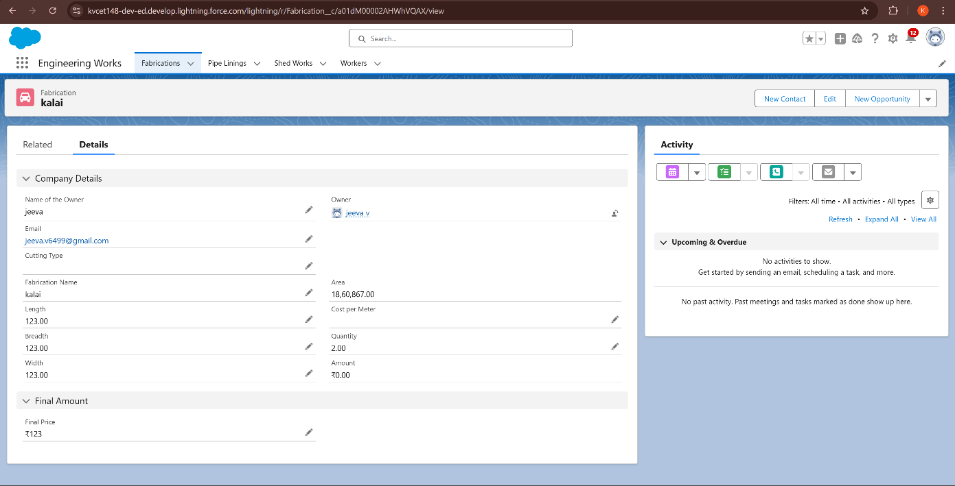

# Conclusion

Salesforce offers a transformative solution for businesses, streamlining operations, enhancing customer engagement, and enabling data-driven decision-making. By centralizing customer data, automating workflows, and providing robust marketing tools like Marketing Cloud, it boosts efficiency, personalizes interactions, and drives ROI. Its integration capabilities ensure smooth connectivity across systems, while advanced analytics deliver actionable insights for growth. With strong data security, collaboration tools like Slack, and mobile access, Salesforce supports productivity and consistency. Successful implementation depends on effective training and change management to ensure adoption. Scalable and adaptable, Salesforce empowers businesses to thrive in a dynamic market and achieve sustained success.